**28 Sept 2018** **The Weekly Bulletin of Rotary Club of Kathmandu Mid-Town** **bc-4.9/018**

|  |
| --- |
| C:\Users\Public\Documents\RIP T1819_EN.png |

District: 3292 Web:www.rotarymidtown.org.np Club Id: 26776

**SEPTEMBER IS THE BASIC EDUCATION AND LITERACY MONTH**

**Basic education and literacy is one of Rotary’s six areas of focus.**

Literacy is often associated with the ability to read and write. However, it is also about making sense of and engage in everything we read, write, listen to and talk about.

Literacy and education has the power to change our own inner world, ourselves. It can transform our lives for the better. [For everyone, everywhere, literacy is, along with education in general, a basic human right.](https://www.azquotes.com/quote/863684?ref=education-and-literacy)

‘Education is the most powerful weapon which you can use to change the world’. It’s in this context that The Rotary Foundation’s focus on basic education and literacy needs to be seen.

[Literacy is the road to human progress and the means through which every man, woman and child can realize his or her full potential..](https://www.azquotes.com/quote/811831?ref=education-and-literacy)

Source: www.azquotes.com

**Club Meeting # 1458** : 21 Sept 018

Celebration of 29th Installation of Rotary Club of Kathmandu Mid-Town

went well as per the program on Friday 21 Sept 2018 at Malla Hotel.

Some important moments:

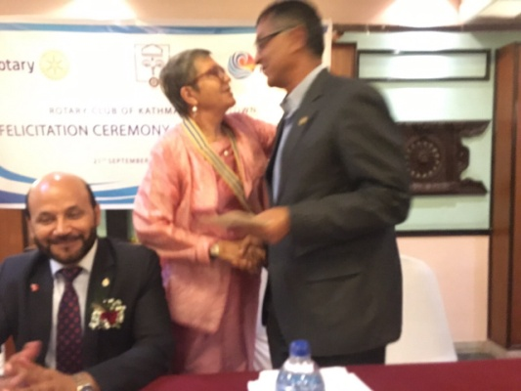 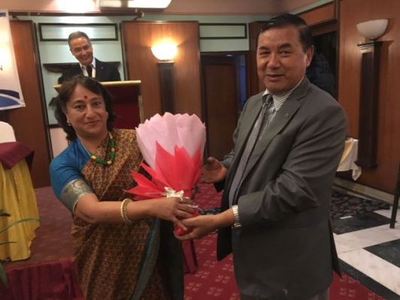 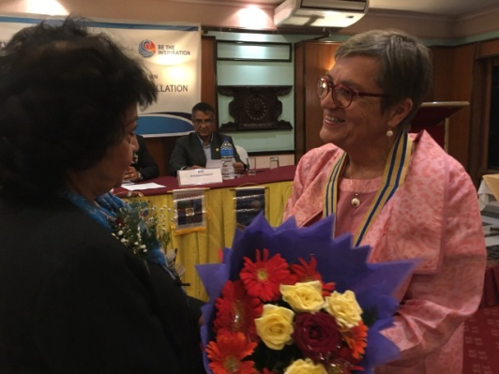

President Jo welcomes IPP Bhairaja Spouses of President Jo and IPP Bhairaja President Jo welcomes PDG Jaya

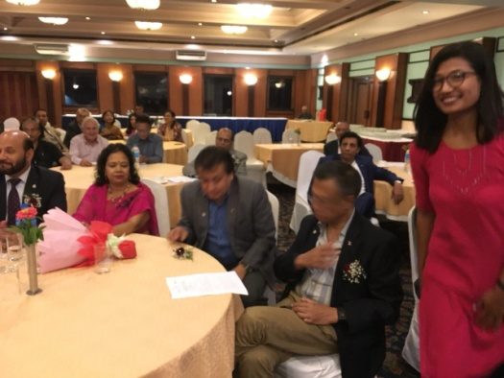 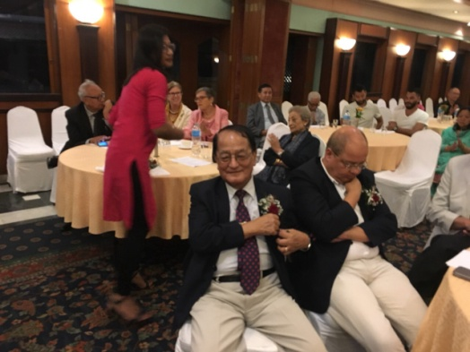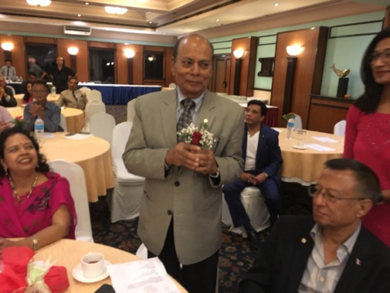

District officials and guests arriving, being welcomed

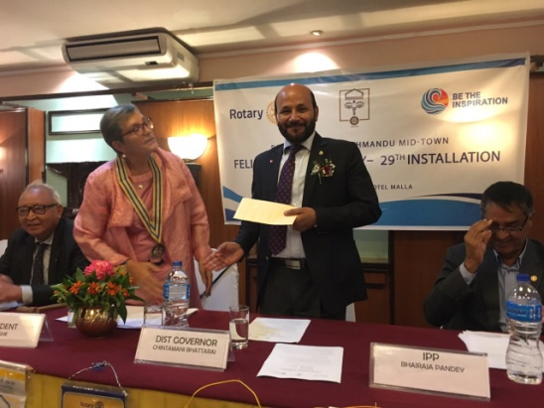 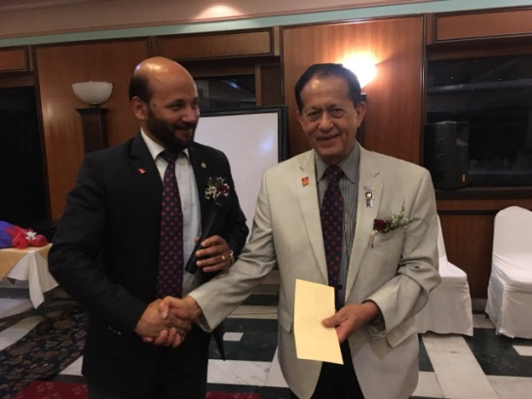 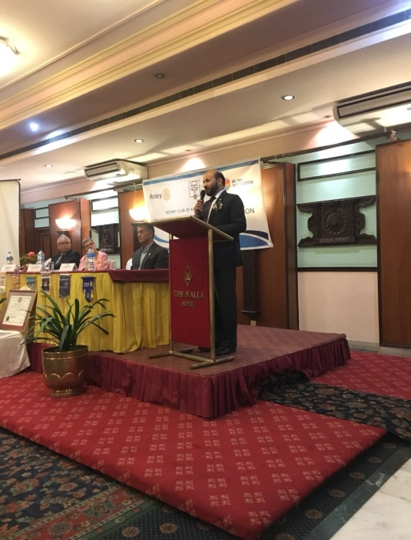

President Jo hand overs cheque to DG DG hands over the cheque to PDG DG Chintamani addressing

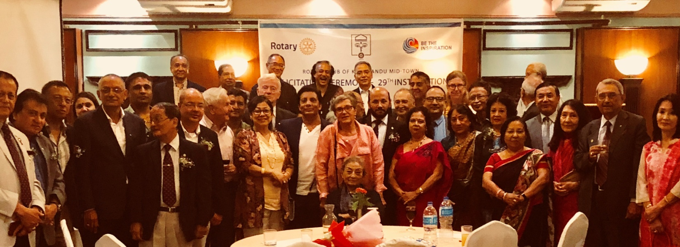

Group photo *Photo courtesy*: PE Rtn Neeva Pradhan

# Weekly Meeting/Program Schedule:

|  |  |  |
| --- | --- | --- |
| Date | Program/ Speaker | Topic of Presentation |
| 28 September | Janadan Dev Pant | Micro Credit In Nepal |

Friday Meeting: 28 Sept

Guest speaker Mr Janardan Dev Pant will give a talk on Micro credit in Nepal

A Technical officer turned banker, Mr Janardan D Pant is the CEO in Nirdhan Utthan Bank Ltd. He has 11 years banking experience in Himalayan Bank Ltd.

**Skills/Vocational Training for Youth:**

A Vocational Training program was organized by Rotary Club of Kathmandu Midtown on Tuesday, 25 Sept 2018 for youths from different institutions including Kathmandu Midtown Rotaracts.

Training sessions on First aid and Life saving skills

Trainers from Emergency Medical Team, and Nepal Ambulance Sevices

Venue: Xavier Academy, Lazimpat (next to Radisson Hotel)

Number of participants - 176 students

The program was designed and organized by PE Rtn Neeva Pradhan in coordination with

Nepal Ambulance Service (NAS) Emergency Medical Team (EMT).

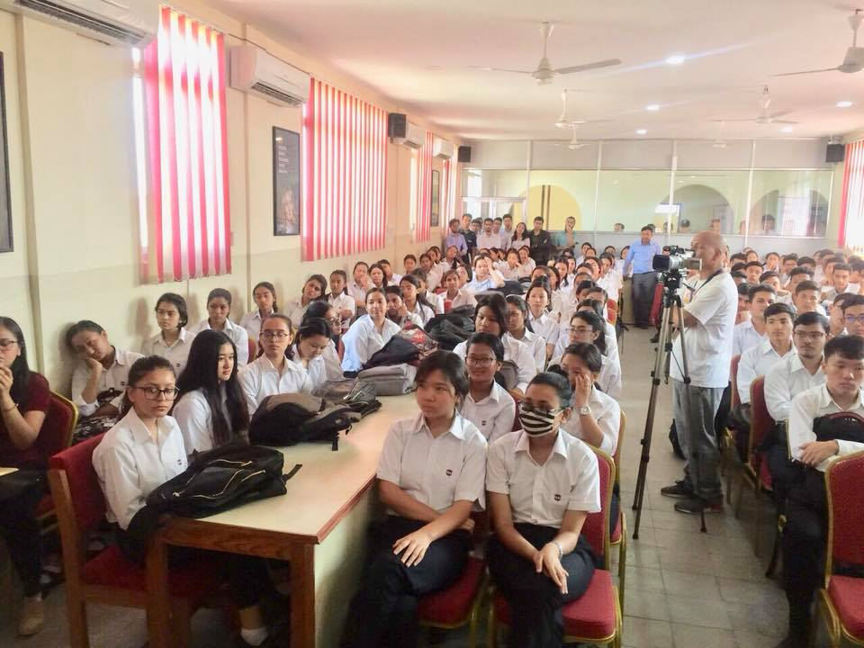

*Photo courtesy*: PE Rtn Neeva Pradhan

**If you do not know!**

Forbes recently came out with its latest list of billionaires and while Jeff Bezos of Amazon has overtaken Bill Gates as the richest man in the world, it has been a record year for women billionaires with an all-time high number of 256 women making it to this exalted place in the 2018 Forbes World’s Billionaire ranking.

What’s most heartening is that even though most of the women on this list have inherited their wealth, more than a quarter of the world’s richest women are ‘self-starters’ who have blazed their own trails. This number has reached 72 for the first time, up from 56 a year ago.

Alice Walton, the only daughter of Walmart founder Sam Walton, reclaimed the crown as the richest woman in the world, with her wealth catapulting from $33.8 billion to $46 billion over the past year.

Two-thirds of self-made female billionaires hail from the two countries: the US and China.

*-* *Rotary News April 2018*

**Ethics and Honesty:**

Two train employees including Naresh Awal from Nepal, currently residing in Sydney, were awarded with Sydney Trains customer service awards and received the ‘Beyond Brilliant’ award for doing an honest deed and returning a wallet containing an astounding $28,600 in cash to its rightful owner in Australia. They were commended for their 'integrity' and 'honesty' by Transport Minister Andrew Constance. (22 Sep 2018)

<http://bit.ly/2NzmlpV>.

**A THOUGHT FOR TODAY:**

**[Those who will not reason, are bigots,](http://www.brainyquote.com/quotes/quotes/g/georgebern102967.html" \o "view quote)**

**[those who cannot, are fools,](http://www.brainyquote.com/quotes/quotes/g/georgebern102967.html" \o "view quote)**

**[and, those who dare not, are slaves.](http://www.brainyquote.com/quotes/quotes/g/georgebern102967.html" \o "view quote)**

[***[Lord Byron](http://thinkexist.com/quotation/knowing_a_great_deal_is_not_the_same_as_being/198021.html)***](http://www.brainyquote.com/quotes/authors/g/george_bernard_shaw.html)

**Committee Chairs’ Column:** *(This column is for use by chairpersons of 5 permanent committees: Club Administration, Membership, Public Relations, Service Projects, and the Rotary Foundation)*

**Members’ Corner:** *(This column is for Club members to express anything they would like in matter of Club activities, Club administration, Club issues or on Breakfast Chatter, or on anything else that would be of interest to fellow members.)*

**Do you know?**

Scientists may finally have an answer to why [eggs](http://vis.sciencemag.org/eggs/) come in different shapes and, apparently, it is all down to the bird’s flying ability. It seems the best fliers are the ones that lay more ‘pointy’ or elliptical shaped eggs while the others are more likely to lay rounded or oval-shaped eggs.

*The Irish Time*

On Lighter Side:

A blonde woman was speeding down the road in her little red sport car and was pulled over by a woman police officer who was also a blonde.

The blonde cop asked to see the blonde driver's license. She dug through her purse and was getting progressively more agitated. ''What does it look like?'' she finally asked.

The policewoman replied, ''It's square, and it has your picture on it.

''The driver finally found a square mirror in her purse, looked at it and handed it to the policewoman. ''Here it is,'' she said.

The blonde officer looked at the mirror, then handed it back saying, "OK, you can go. I didn't realize you were a cop!"

**Photos source:**

*Courtsey:* 29th Installation Celebration photos are from Rtn Shyam R Thapalia. Many thanks!

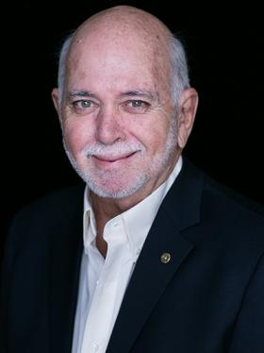

Let's not keep Rotary's story - the story captured in those snapshots of service – to ourselves.

I challenge you to invite leaders of all ages, men and women, who are looking for a way to give

back. By doing so, you will *Be the Inspiration* in your community and help Rotary continue to do

good in the world.

**RI President Barry Rassin**

Please send information on club activities, progress reviews on service projects, relevant photos etc to:

BC Editor: RR Shrestha email: rryesrr@gmail.com

## 28 Sept 2018 The Weekly Bulletin of Rotary Club of Kathmandu Mid-Town bc-4.9/018